**Phase Controlled Rectifier**

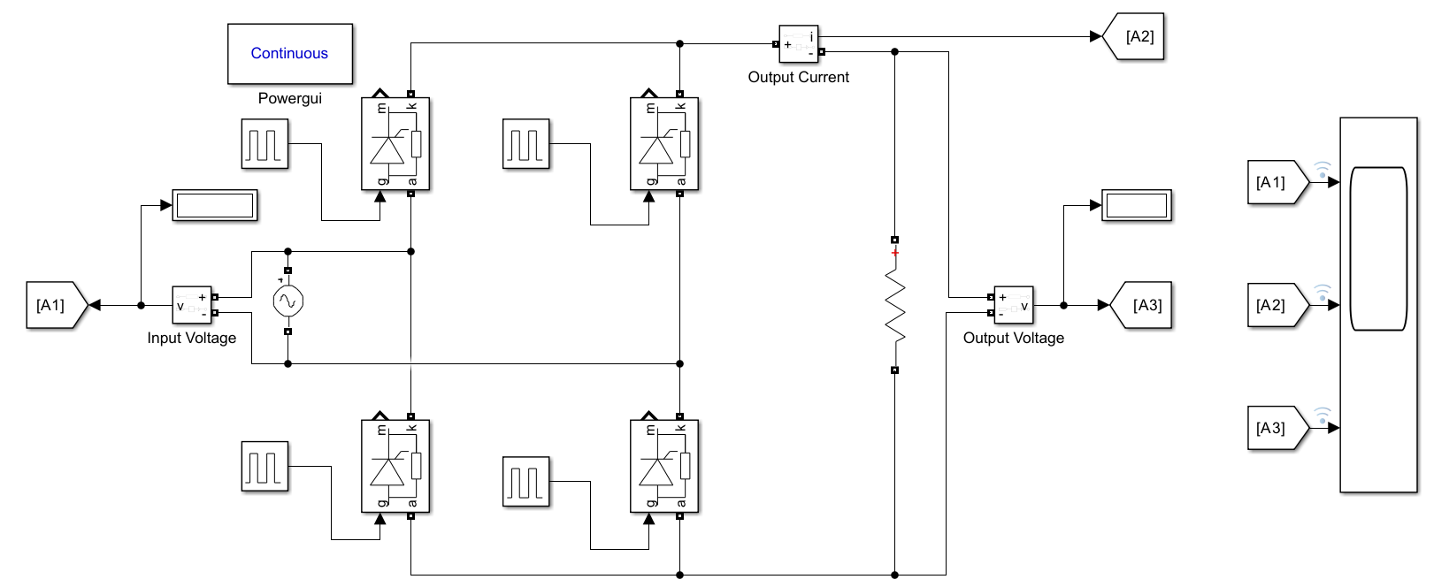

**Fig. Block Diagram of Phase Controlled Rectifier**



**Fig. Characteristics of Phase Controlled Rectifier**

**PWM Rectifier**

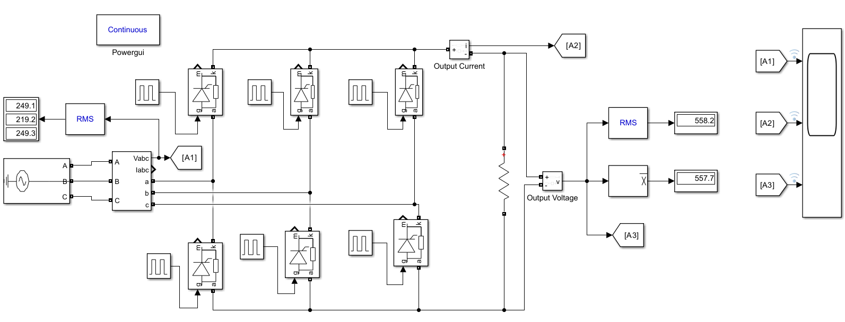

**Fig. Block Diagram of PWM Rectifier**



**Fig. Characteristics of PWM Rectifier**